**Implications of the (changing) relationship between life expectancy and lifespan inequality**

José Manuel Aburto, Ginevra Floridi and Ella Fegitz

**Abstract**: Life expectancy at birth is widely employed to measure longevity. However, as José Manuel Aburto, Ginevra Floridi and Ella Fegitz another dimension is of great relevance in health research and policy intervention: inequality in the length of life. This can be measured with a simple index.

**BIO**

José Manuel Aburto. Department of Sociology & Leverhulme Centre for Demographic Science, University of Oxford, UK; and Interdisciplinary Centre on Population Dynamics, University of Southern Denmark.

Ginevra Floridi. Department of Global Health & Social Medicine, King’s College London, UK.

Ella Fegitz. Department for the Study of Culture & Interdisciplinary Centre on Population Dynamics, University of Southern Denmark.

**What are life expectancy and lifespan inequality?**

Life expectancy at birth is a measure of the mean level of mortality. Simply put, it expresses the average number of years a newborn is expected to live given the mortality conditions at a point in time. Because it is an average, life expectancy does not show differences in length of life among people; however, these can be substantial. Differences in lifespans are usually captured by a metric of variation or inequality in ages at death, and they are usually referred to by demographers as *lifespan inequality.*

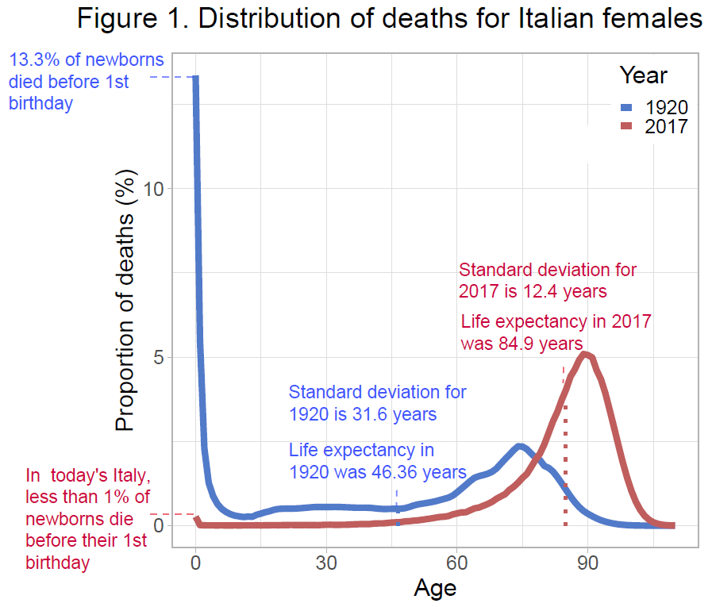Lifespan inequality at the individual level tells us how unpredictable the timing of death is. In other words, how long a newborn in 1920’s Italy - with lifespan inequality of 31.6 years measured by the standard deviation of ages at death (SD) – was going to live was considerably more difficult to predict than it is for a baby born in contemporary Italy (SD of 12.4 years), because deaths were more spread over age in the former (Figure 1). At the societal level, this may be considered as the most fundamental of all inequalities (van Raalte, Sasson, & Martikainen, 2018): its level and the evolution can tell much of how equitable health improvements are allocated in a society.

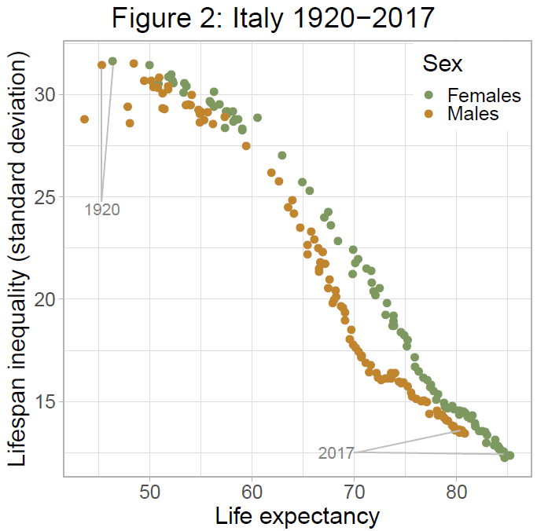**How does life expectancy relate with lifespan inequality?**

In 1920, 13.3% of females born in Italy died before their first birthday and less than 10% of them were expected to reach the age of 82 years. In contrast, 99.7% of female babies born in 2017 survived to their first birthday and almost 70% of them are expected to be alive in 2100 (Figure 1). This exceptional progress on reducing mortality has meant that life expectancy at birth increased from 46.4 years to almost 85 years over the last century, and at the same time, that life chances have been more equitable or that lifespan inequality decreased (Figure 2).

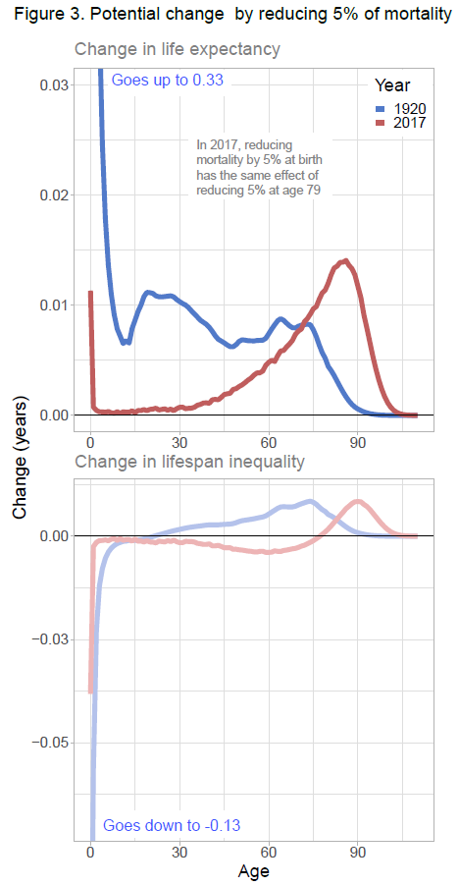Higher levels of life expectancy usually correspond to lower levels of lifespan inequality (e.g. Smits and Monden 2009). A recent article shows that changes in both life expectancy and lifespan inequality can be expressed as rates of progress in reducing mortality (Aburto et al 2020). For example, in 1920 the biggest gains in life expectancy were achieved if progress was concentrated at infancy. In today’s Italy, reducing infant death rates by 5% leads to the same gain in life expectancy of reducing 5% mortality at age 79 (Figure 3). This has potential implications for the relationship between life expectancy and lifespan inequality. Saving lives at infancy increases life expectancy and reduces lifespan inequality; however, if progress is placed in ages above age 79 life expectancy and lifespan inequality would increase (Figure 3).

**Societal implications of increased lifespan inequality**

If both long lives and equal lifespans matter, we can think of the best possible scenario as one where people not only live longer, but also face progressively less uncertainty around when they will die. However, this has not always been the case as – in certain countries, during specific periods - lifespan inequality has been shown to stall or even increase despite improvements in life expectancy, or vice versa. During 1960-1980 in Central and Eastern Europe, life expectancy and lifespan inequality moved independent of each other more than half of the time largely due to changes in mortality at midlife (Aburto et al 2020). Similarly, among males in Venezuela from 1996 to 2013, life expectancy increased (69.4 to 71 years) together with lifespan inequality (SD from 20.7 to 21.7 years). This resulted from progress made at almost all ages including infant mortality offset by increased violent deaths concentrated among young males (García & Aburto, 2019).

The weakening or reversal of the negative relationship between lifespan inequality and life expectancy means that, while people live longer on average, individuals also face greater uncertainty around when they will die. Differences in lifespan inequality are critical because, in making important life decisions, people are influenced by the mortality experience of those around them. Higher uncertainty will affect decisions such as whether and when to invest in education, migrate, buy a house, or retire. Studies have shown that, within a society, such increased uncertainty is likely to be concentrated among those from disadvantaged socio-economic groups. In Finland over the period 1971-2014, subgroups with low education level and with the lowest income increased lifespan inequality while those from more-advantaged groups reduced lifespan inequality (van Raalte et al., 2018). Diverging patterns in lifespan inequality by socioeconomic groups may have important consequences for the perpetuation of social inequalities. For instance, faced with greater uncertainty about their own lifespan, individuals from disadvantaged socio-economic backgrounds risk making unfavorable financial decisions and this could further reduce their financial resources later in life. Lifespan inequality is also likely to create uncertainty about the timing of inheritances and financial bequests among family members. If this uncertainty is concentrated among lower socio-economic groups, poorer individuals may not only receive smaller transfers from their parents and grandparents than the rich; they may also be less able to plan around the timing of those transfers. Given the importance of these transfers for the recipients’ socio-economic conditions, higher lifespan inequality may strengthen the transmission of disadvantage across generations, reducing intergenerational social mobility.

**The significance of including lifespan inequality in policy and research**

Increasing the average age at death alone is not enough for guaranteeing a more equitable distribution of the length of life. An important message of this research is that policies and interventions can affect this relationship by reducing mortality at the ages that matter the most. In terms of policy interventions, one important question to ask is how different types of healthcare investments, such as preventive as opposed to end-of-life care, may relate to inequality in lifespans. Another important question is how the strength of the relationship between life expectancy and lifespan inequality varies across societies and periods characterized by different levels of social inequality. There is reason to believe that more equal or socially cohesive societies may be more effective at reducing lifespan inequality, for example through reductions in violent crimes or greater access to preventive healthcare across all socio-economic groups. These are promising avenues for future research linking demographic phenomena to the broader societal context in which they take place, with important implications for social policy.

**References**

[Aburto, J. M., Villavicencio, F., Basellini, U., Kjærgaard, S., & Vaupel, J. W. (2020). Dynamics of life expectancy and life span equality. *Proceedings of the National Academy of Sciences*.](https://doi.org/10.1073/pnas.1915884117)

García, J., & Aburto, J. M. (2019). The impact of violence on Venezuelan life expectancy and lifespan inequality. *International journal of epidemiology*.

Smits, J., & Monden, C. (2009). Length of life inequality around the globe. *Social Science & Medicine, 68*(6), 1114-1123.

van Raalte, A. A., Sasson, I., & Martikainen, P. (2018). The case for monitoring life-span inequality. *Science, 362*(6418), 1002-1004.